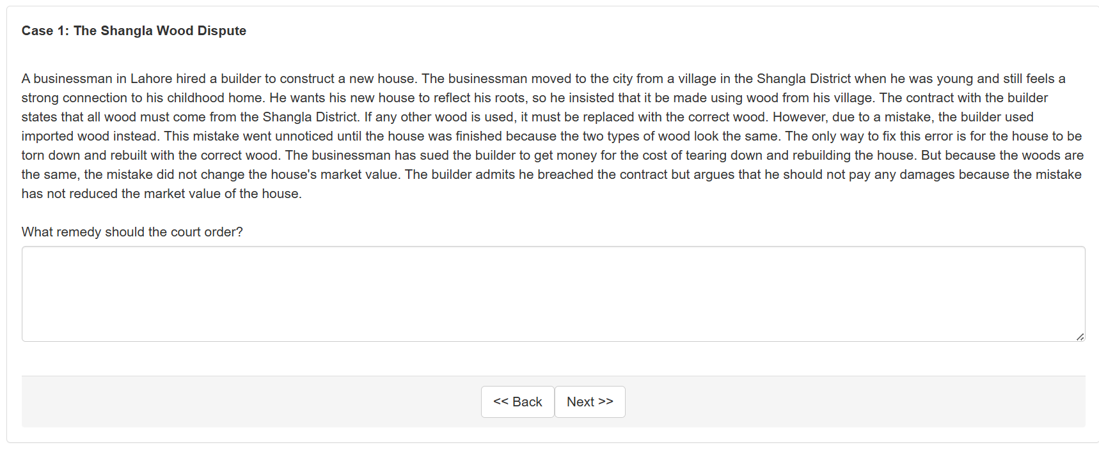

Please rate the following remedies for how well they achieve each of three values—efficiency, corrective justice, distributive justice. Also, please say where each remedy falls on the spectrum between formalism and functionalism.

A. The total cost to knock down the house and build a new one with wood from the Shangla District

1 2 3 4 5 6 7 8 9
least efficient most efficient

1 2 3 4 5 6 7 8 9
least correctively just most correctively just

1 2 3 4 5 6 7 8 9
least distributively just most distributively just

1 2 3 4 5 6 7 8 9
purely formalist purely functionalist

B. The difference between the value of the house as it is and what it would have been worth had it been made with Shangla wood, which is zero.

1 2 3 4 5 6 7 8 9
least efficient most efficient

1 2 3 4 5 6 7 8 9
least correctively just most correctively just

1 2 3 4 5 6 7 8 9
least distributively just most distributively just

1 2 3 4 5 6 7 8 9
purely formalist purely functionalist

C. The court’s best guess of how much money it would take to compensate the businessman for his disappointment at not having a house made with Shangla wood.

1 2 3 4 5 6 7 8 9
least efficient most efficient

1 2 3 4 5 6 7 8 9
least correctively just most correctively just

1 2 3 4 5 6 7 8 9
least distributively just most distributively just

1 2 3 4 5 6 7 8 9
purely formalist purely functionalist

D. The money saved by the builder for using imported wood instead of Shangla wood.

1 2 3 4 5 6 7 8 9
least efficient most efficient

1 2 3 4 5 6 7 8 9
least correctively just most correctively just

1 2 3 4 5 6 7 8 9
least distributively just most distributively just

1 2 3 4 5 6 7 8 9
purely formalist purely functionalist

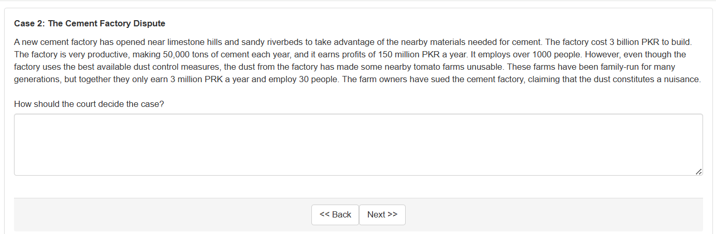

Please rate the following remedies for how well they achieve each of three values—efficiency, corrective justice, distributive justice. Also, please say where each remedy falls on the spectrum between formalism and functionalism.

A. The cement factory does not constitute a nuisance.

1 2 3 4 5 6 7 8 9
least efficient most efficient

1 2 3 4 5 6 7 8 9
least correctively just most correctively just

1 2 3 4 5 6 7 8 9
least distributively just most distributively just

1 2 3 4 5 6 7 8 9
purely formalist purely functionalist

B. The cement factory constitutes a nuisance, and the remedy is damages for the economic loss that the dust imposes on the farm-owners.

1 2 3 4 5 6 7 8 9
least efficient most efficient

1 2 3 4 5 6 7 8 9
least correctively just most correctively just

1 2 3 4 5 6 7 8 9
least distributively just most distributively just

1 2 3 4 5 6 7 8 9
purely formalist purely functionalist

C. The cement factory constitutes a nuisance, and the is an injunction halting the factory’s operation.

1 2 3 4 5 6 7 8 9
least efficient most efficient

1 2 3 4 5 6 7 8 9
least correctively just most correctively just

1 2 3 4 5 6 7 8 9
least distributively just most distributively just

1 2 3 4 5 6 7 8 9
purely formalist purely functionalist

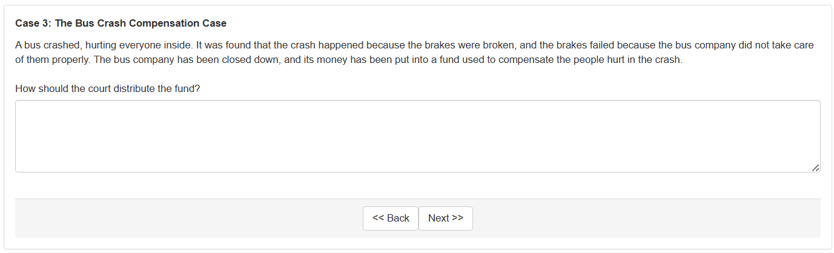

Please rate the following remedies for how well they achieve each of three values—efficiency, corrective justice, distributive justice. Also, please say where each remedy falls on the spectrum between formalism and functionalism.

A. So that those who have the most serious medical injury get the most.

1 2 3 4 5 6 7 8 9
least efficient most efficient

1 2 3 4 5 6 7 8 9
least correctively just most correctively just

1 2 3 4 5 6 7 8 9
least distributively just most distributively just

1 2 3 4 5 6 7 8 9
purely formalist purely functionalist

B. So that those who lost the most wages get the most.

1 2 3 4 5 6 7 8 9
least efficient most efficient

1 2 3 4 5 6 7 8 9
least correctively just most correctively just

1 2 3 4 5 6 7 8 9
least distributively just most distributively just

1 2 3 4 5 6 7 8 9
purely formalist purely functionalist

C. So that those whose injuries can be cured by expensive medical care get more compensation than those whose injuries are incurable.

1 2 3 4 5 6 7 8 9
least efficient most efficient

1 2 3 4 5 6 7 8 9
least correctively just most correctively just

1 2 3 4 5 6 7 8 9
least distributively just most distributively just

1 2 3 4 5 6 7 8 9
purely formalist purely functionalist
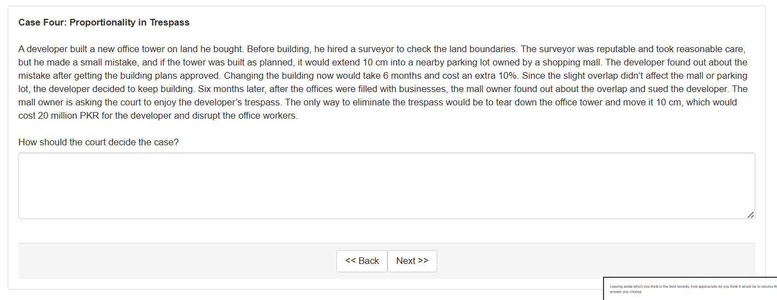

Please rate the following remedies for how well they achieve each of three values—efficiency, corrective justice, distributive justice. Also, please say where each remedy falls on the spectrum between formalism and functionalism.

A. The developer did not commit a trespass.

1 2 3 4 5 6 7 8 9
least efficient most efficient

1 2 3 4 5 6 7 8 9
least correctively just most correctively just

1 2 3 4 5 6 7 8 9
least distributively just most distributively just

1 2 3 4 5 6 7 8 9
purely formalist purely functionalist

B. The developer committed a trespass, and the remedy is the reduction in the value of the mall and its parking lot, which is zero.

1 2 3 4 5 6 7 8 9
least efficient most efficient

1 2 3 4 5 6 7 8 9
least correctively just most correctively just

1 2 3 4 5 6 7 8 9
least distributively just most distributively just

1 2 3 4 5 6 7 8 9
purely formalist purely functionalist

C. The developer committed a trespass, and the remedy is an injunction to tear down the office tower and move it to eliminate the encroachment.

1 2 3 4 5 6 7 8 9
least efficient most efficient

1 2 3 4 5 6 7 8 9
least correctively just most correctively just

1 2 3 4 5 6 7 8 9
least distributively just most distributively just

1 2 3 4 5 6 7 8 9
purely formalist purely functionalist
D. The developer committed a trespass, and the remedy is disgorgement of the construction costs saved by the decision to build rather than redesigning the building and getting renewed planning permission.

1 2 3 4 5 6 7 8 9
least efficient most efficient

1 2 3 4 5 6 7 8 9
least correctively just most correctively just

1 2 3 4 5 6 7 8 9
least distributively just most distributively just

1 2 3 4 5 6 7 8 9
purely formalist purely functionalist

